COM 370
Nathaniel Gagliardo
I didn’t have too much of an idea for this “self-portrait.” I’m not that talented at coding, so I figured to just play it safe and just put on some images and some text about myself. I had a lot of trouble putting together images and putting them on the website I was creating. I had to do some converting because some of the images came from my phone and Visual Studio Code doesn’t read .HEIC files, so I had to spend some time converting the photos from my phone to .PNG files.
So I figured to play it safe and keep it simple: just put in some facts about me and what I enjoy and call it a day. I didn’t want to go all fancy and make anything interactive because the adventure website game from last week gave me a hard time. Several times, the links gave me error messages while I was making them. At first, I didn’t know what to make this self-portrait about or what to even put on there, but I eventually managed to figure things out, eventually landing on the Desktop Dump by Molly Soda, one of the examples that we were given, as my main inspiration for this project: just put a bunch of stuff onto a screen that makes you… well, you.
Here’s a bit of my code I used to make the website:
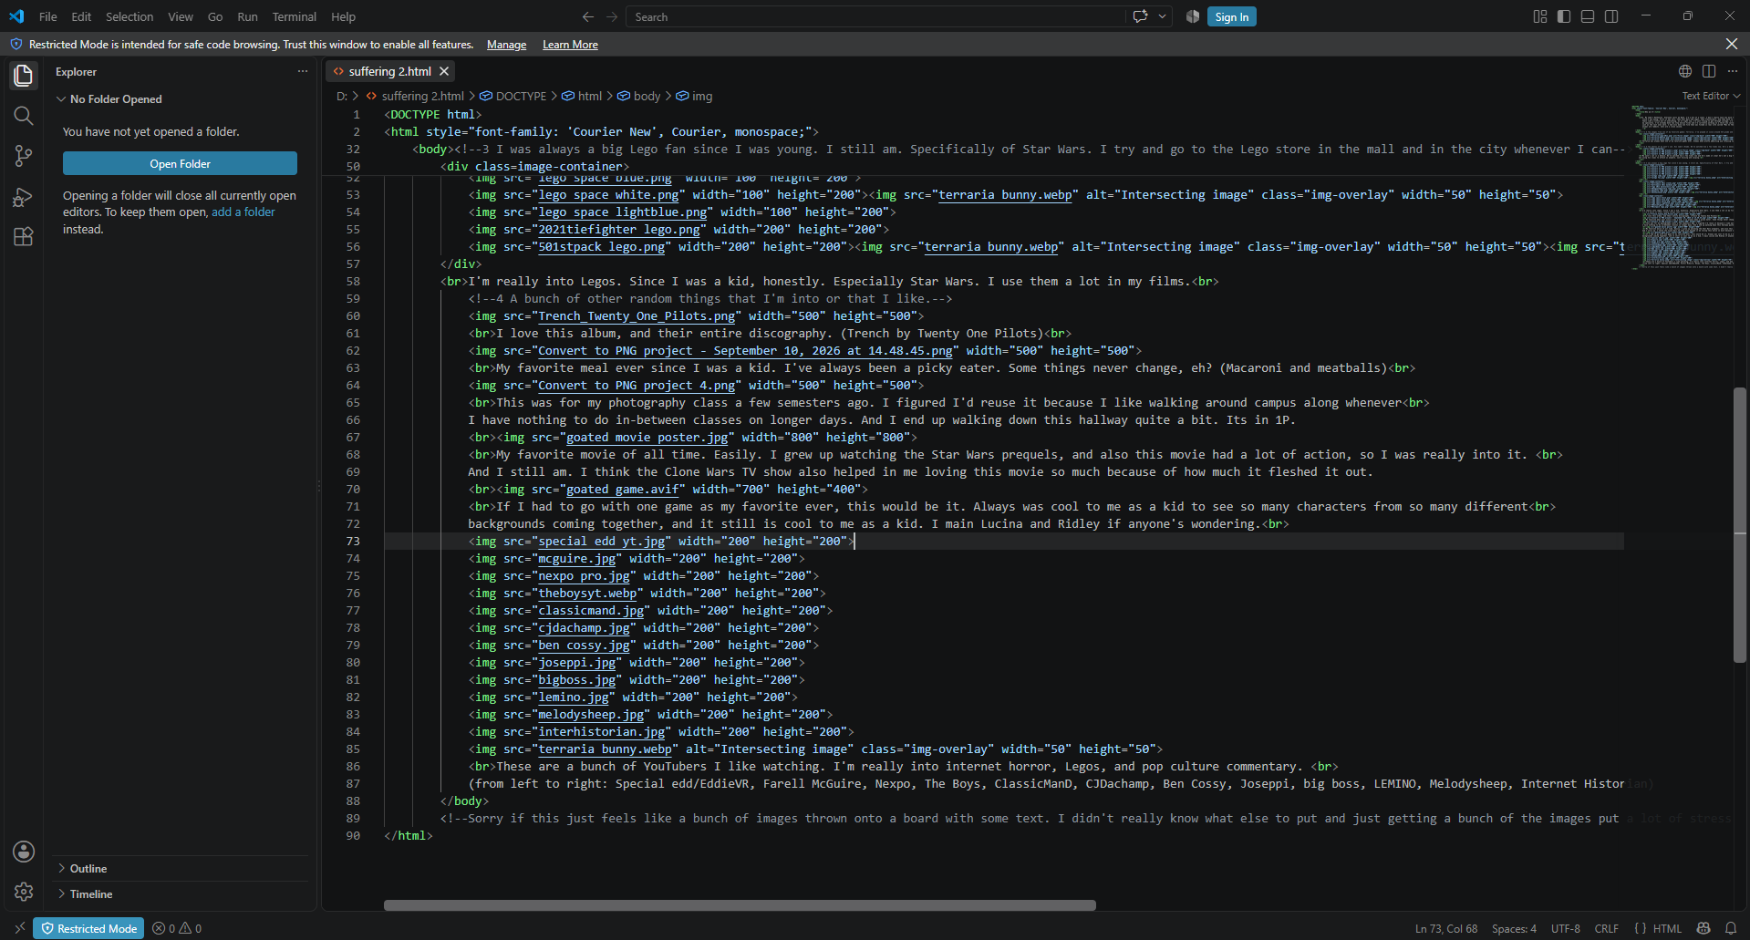
I don’t know if I did everything correctly. Sorry if I didn’t…. I didn’t do this correctly, did I?

